Week 6 - Static Routing Configuration Lab using Four Routers and total six network

Objective - Static Routing Configuration using Four Routers and total six network.
This is simply a static Routing Configuration Lab Showing and Explaining Static Route Configuration using four Routers in a cisco packet tracer. Use Router type 2911.
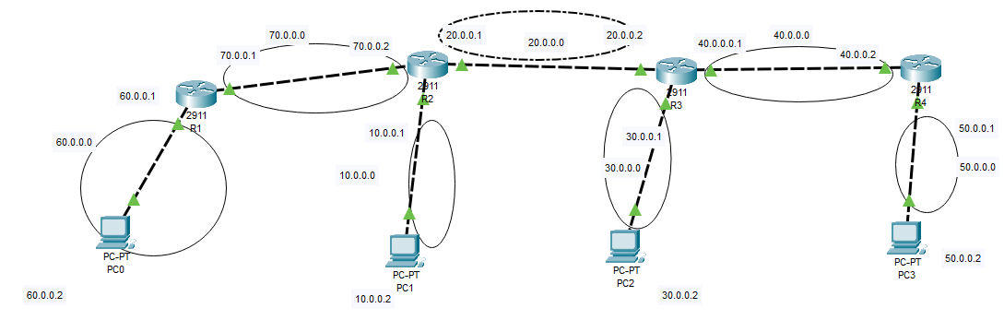

Step 1: Draw the Topology diagram as mentioned in above diagram.

Step 2: Assigned IP address on Each PC with gateway IP.
For Example, I have mentioned one image below.
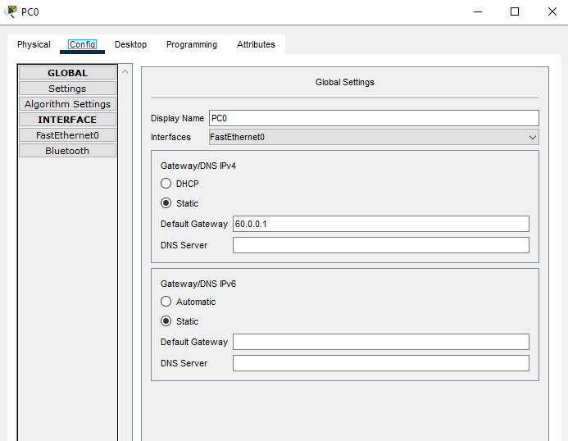
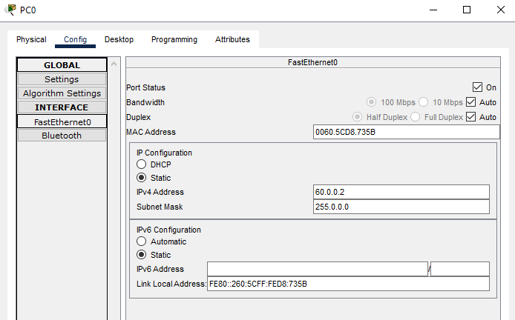
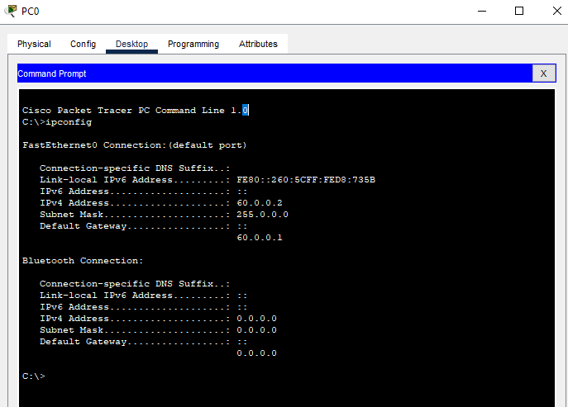

Step 3: Assign IP Address on each Router One by One:

First Going to Assign IP address on Router R1

R1(config)#host R1
R1(config)#int Gig0/0
R1(config-if)#ip add 60.0.0.1 255.0.0.0
R1(config-if)#no shut
R1(config-if)#exit
R1(config)#int Gig0/1
R1(config-if)#ip add 70.0.0.1 255.0.0.0
R1(config-if)#no shut
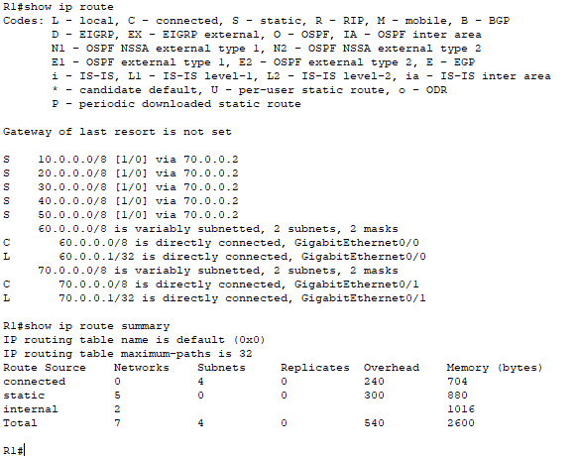

Now Going To Assign IP Address on Router R2

Router(config)#host R2
R2(config)#int Gig0/0
R2(config-if)#ip add 70.0.0.2 255.0.0.0
R2(config-if)#no shut
R2(config-if)#exit
R2(config)#int Gig0/1
R2(config-if)#ip add 20.0.0.1 255.0.0.0
R2(config-if)#no shut
R2(config-if)#exit
R2(config)#int Gig0/2
R2(config-if)#ip add 10.0.0.1 255.0.0.0
R2(config-if)#no shut

Now Assign IP Address on Router R3:

Router(config)#host R3
R3(config)#int Gig0/1
R3(config-if)#ip add 30.0.0.1 255.0.0.0
R3(config-if)#no shut
R3(config-if)#exit
R3(config)#
R3(config)#int Gig 0/1
R3(config-if)#ip add 20.0.0.2 255.0.0.0
R3(config-if)#no shut
R3(config-if)#exit
R3(config)#int Gig0/2
R3(config-if)#ip add 40.0.0.1 255.0.0.0
R3(config-if)#no shut

Now assign IP Address on Router R4:

Router(config)#host R4
R4(config)#int Gig0/0
R4(config-if)#ip add 40.0.0.2 255.0.0.0
R4(config-if)#no shut
R4(config-if)#exit
R4(config)#int Gig0/1
R4(config-if)#ip add 50.0.0.1 255.0.0.0
R4(config-if)#no shut

Step 4: Now it’s Time to configure Static Route over all those Four Routers R1, R2, R3 and R4

Static Routing Configuration on Router R1:

R1(config)#ip route 10.0.0.0 255.0.0.0 70.0.0.2
R1(config)#ip route 20.0.0.0 255.0.0.0 70.0.0.2
R1(config)#ip route 30.0.0.0 255.0.0.0 70.0.0.2
R1(config)#ip route 40.0.0.0 255.0.0.0 70.0.0.2
R1(config)#ip route 50.0.0.0 255.0.0.0 70.0.0.2

Static Routing Configuration on Router R2:

R2(config)#ip route 30.0.0.0 255.0.0.0 20.0.0.2
R2(config)#ip route 40.0.0.0 255.0.0.0 20.0.0.2
R2(config)#ip route 50.0.0.0 255.0.0.0 20.0.0.2
R2(config)#ip route 60.0.0.0 255.0.0.0 70.0.0.1

Static Routing Configuration on Router R3:

R3(config)#ip route 10.0.0.0 255.0.0.0 20.0.0.1
R3(config)#ip route 60.0.0.0 255.0.0.0 20.0.0.1
R3(config)#ip route 70.0.0.0 255.0.0.0 20.0.0.1
R3(config)#ip route 50.0.0.0 255.0.0.0 40.0.0.2

Static Routing Configuration on Router R4:

R4(config)#ip route 10.0.0.0 255.0.0.0 40.0.0.1
R4(config)#ip route 20.0.0.0 255.0.0.0 40.0.0.1
R4(config)#ip route 30.0.0.0 255.0.0.0 40.0.0.1
R4(config)#ip route 60.0.0.0 255.0.0.0 40.0.0.1
R4(config)#ip route 70.0.0.0 255.0.0.0 40.0.0.1

At the End test the communication between two PC to test whether your Routing is properly configured or not.

First Check the IP Address of PC:
PC>ipconfig
FastEthernet0 Connection:(default port)
Link-local IPv6 Address.........: FE80::210:11FF:FEC8:A547
IP Address......................: 50.0.0.2
Subnet Mask.....................: 255.0.0.0
Default Gateway.................: 50.0.0.1

Then Ping with another PC:

PC>ping 60.0.0.2
Pinging 60.0.0.2 with 32 bytes of data:
Request timed out.
Reply from 60.0.0.2: bytes=32 time=3ms TTL=124
Reply from 60.0.0.2: bytes=32 time=3ms TTL=124
Reply from 60.0.0.2: bytes=32 time=15ms TTL=124
Ping statistics for 60.0.0.2:
Packets: Sent = 4, Received = 3, Lost = 1 (25% loss),
Approximate round trip times in milli-seconds:
Minimum = 3ms, Maximum = 15ms, Average = 7ms

You can see another PC is Receiving the Packets. It means It’s working fine.
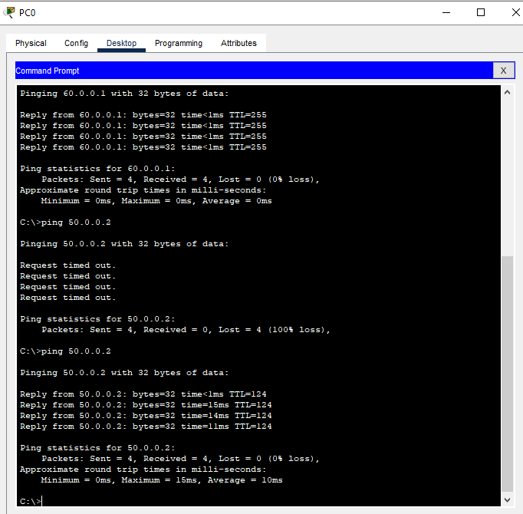

Explore the show commands. Use the information displayed by these show commands to answer the questions in the Reflection section.
a. Type show arp.
b. Type show flash.
c. Type show ip route.
d. Type show interfaces.

e. Type show protocols.
f. Type show users.
g. Type show ver

